How to configure AP Mode for W150M?
Product line: Wireless Question category: function configurations

Q：When we need to configure the W150M as AP Mode?
A：The W150M worked as a converter between the wired and wireless signal with AP mode. If you already have wired router and want to connect to the Internet wirelessly on laptops, Connect the W150M to the router’s LAN port with Ethernet cable, then all the wireless clients can access the Internet wirelessly.

Common network connection topology is as follows.
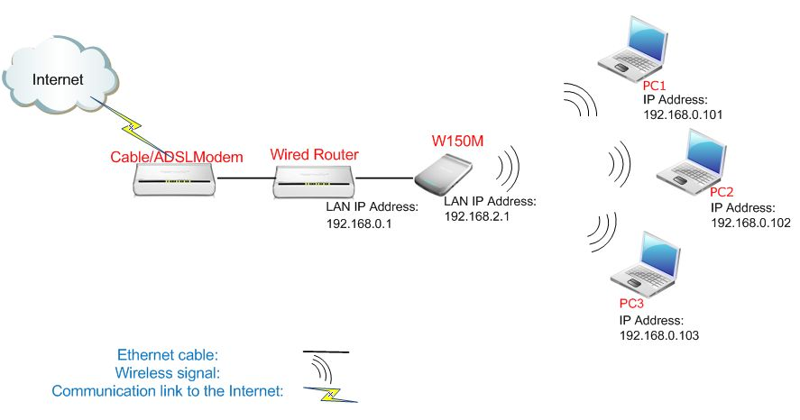

Steps are as follows:
- Connect your computer to the port of W150M with Ethernet cable.
- Login to the management page of the W150M. (The login IP is default to be 192.168.2.1; the username and password are both admin).
- In the management page, choose the default mode Wireless AP->Setup Wizard. In the set up Wizard page, click next.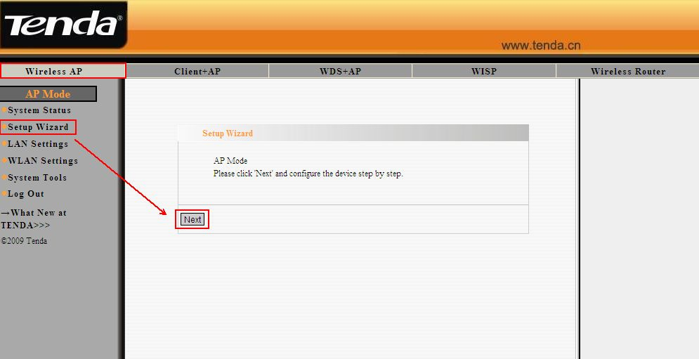
- In the Wireless Basic Setting page, you can do the basic configuration for your W150M. You can change the name of your W150M by changing the SSID and choose the wireless Channel. Click Next.
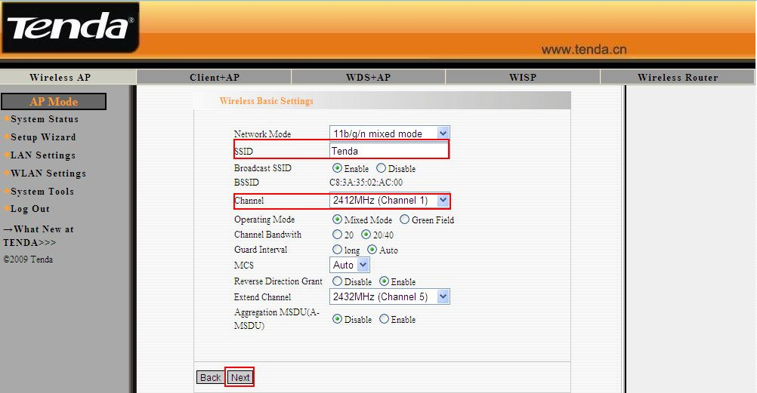
5．In the Wireless Security Settings page, please choose WPA-Personal as Security Mode and choose AES as WPA Algorithms. And type password for wireless network in the blank of Pass Phrase. Click Next. 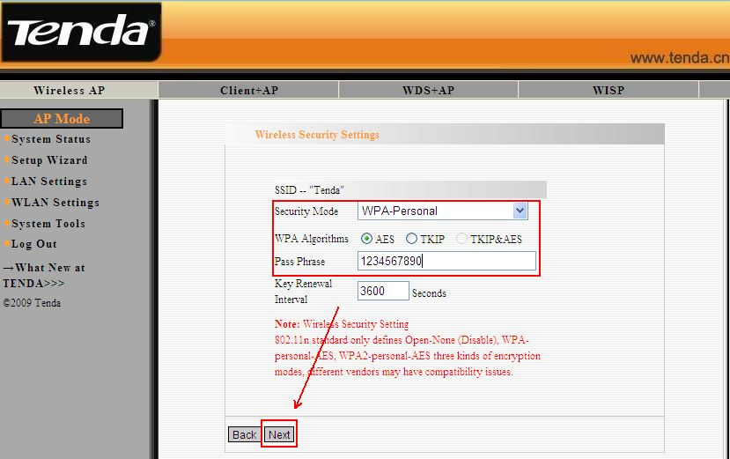
6．Click Apply to save the Settings.
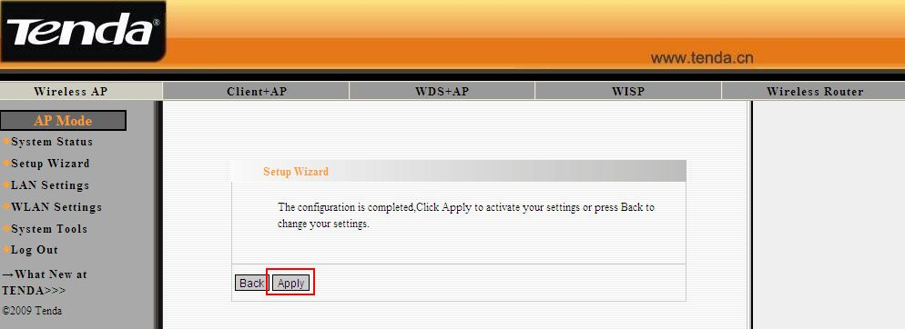
7．Connect your W150M to wired router’s LAN port with Ethernet cable, and the computer connect to the W150M wirelessly will get the ip address from uplink router and connect to the internet normally.

